**QUICK SORT**

**Aim-** Write a C program to implement Quick Sort on array of integers

**Problem Statement –** Given a array of integers implement quick sort to sort the array of integers in assending order

**INPUT -**  The number of elements in the array = 11

- Array Elements – 34,56,-19,26,58,38,30,-24,22,35,76

**OUTPUT –** Display each step of quick sort along with i,j,pivot and show the sorted array

**ALGORITHM –**

# i] Algorithm QuickSort (p,q)

// Sorts the array elements a[p],a[p+1] on global array a[0-n-1] are arranged in such a way //that they are in ascending order

{

If (p<q) then

{ j := partition (a,p,q+1); quicksort( p,j-1) ; quicksort(j+1,q) ; } }

# ii] Algorithm Partition(a,m,q)

//Within a[m],a[m+1]…… a[p-1] the elements are rearranged in such a manner that if

// initially t= a[m] ,then after completion a[q] = t for some q between m and p-1 ;

// a[k] <=t for some m<=k<=q , and a[k] >= t for some q<k<p , q is returned

{ v := a[m] ; i := m ; j : = p ;

repeat { repeat { i := i+1 ; } until (a[i] >=v) ; repeat { j := j+1 ; until (a[j] <=v) ;

if (i < j ) {

temp := a[i] ; a[i] = a[j] ;

a[j] = temp ; } until (i>=j) ; a[m] = a[j] ;

a[j] : = v ; return j ; }

**Space and Time Complexity :**

**I ] Algorithm QuickSort**

**Time Complexity:**

1. **Best Case:**
   * **O(n log n)**
   * The pivot divides the array into two equal halves at every step, minimizing recursion depth.
2. **Worst Case:**
   * **O(n²)**
   * The pivot is always the smallest or largest element, leading to one side of the partition having all the elements, and recursion proceeds linearly.
3. **Average Case:**
   * **O(n log n)**
   * On average, the pivot divides the array into reasonably balanced partitions, resulting in logarithmic recursion depth.

**Space Complexity:**

1. **Best Case:**
   * **O(log n)**
   * For recursive calls, the stack depth is proportional to the logarithm of the size of the array, as the array is divided into balanced halves.
2. **Worst Case:**
   * **O(n)**
   * In the worst case, the stack depth is equal to the size of the array due to unbalanced partitions. iii) **Average Case:**
   * **O(log n)**
   * On average, the stack depth remains logarithmic.

**II] Algorithm Partition**

**Time Complexity:**

1. **Best Case:**
   * **O(n)**
   * All elements are scanned and rearranged once relative to the pivot.
2. **Worst Case:**
   * **O(n)**
   * Every element is still scanned and rearranged in a single pass regardless of their order.
3. **Average Case:**
   * **O(n)**
   * The partitioning process always involves a single scan of all elements in the subarray.

**Space Complexity:**

1. **Best Case:**
   * **O(1)**
   * Partitioning requires constant auxiliary space for temporary variables.
2. **Worst Case:**
   * **O(1)**
   * No additional space is required apart from the input array and temporary variables.
3. **Average Case:**
   * **O(1)**
   * Space usage remains constant.

**RECURSION EQUATION –**

1. **Quick Sort**

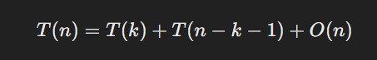

1. **Partition**

The Partition algorithm does not have a recurrence relation because it is not recursive. It is a singlepass operation that rearranges elements relative to a pivot. Its complexity is handled entirely within its single invocation, and no further subproblems are generated. Therefore, no recurrence equation exists for Partition.

**PROGRAM –**

#include <stdio.h>

#define MAX 15

#include <time.h>

int a[MAX];

int n;

void displayArray() {

    int i;

    for (i = 0; i < n; i++) {

        printf("|%d ", a[i]);

    }

    printf("|\n");

}

void partition(int low, int high, int *pp) {

    int i, j, k, pivot, temp;

    pivot = a[low];

    i = low;

    j = high + 1;

    printf(" i = %d , j = %d ,pivot = %d .  \n ", i, j, pivot);

    displayArray();

    while (1) {

        do {

            i++;

        } while (i <= high && a[i] <= pivot);

        do {

            j--;

        } while (a[j] > pivot);

        if (i >= j) {

            break;

        }

        printf("\n");

        temp = a[i];

        a[i] = a[j];

        a[j] = temp;

        printf(" i = %d , j = %d ,pivot = %d . ( i , j interchanged )\n  ", i, j, pivot);

        printf("\n");

        displayArray();

    }

    temp = a[low];

    a[low] = a[j];

    a[j] = temp;

    *pp = j;

    printf("\n i = %d , j = %d ,pivot = %d . (pivot exchanged ) \n ", i, j, pivot);

    displayArray();

}

void quicksort(int low, int high) {

    int p;

    if (low < high) {

        partition(low, high, &p);

        quicksort(low, p - 1);

        quicksort(p + 1, high);

    }

}

int main() {

          printf ("*****************************************************");

    printf ("\n Roll number: 23B-CO-010\n");

    printf (" PR Number - 202311390\n");

    printf("*****************************************************\n\n\n");

    int choice, i;

     clock_t start, end;

    double cpu_time_used;

    do {

        printf("Menu:\n");

        printf("1. Enter array elements\n");

        printf("2. Sort array using Quicksort\n");

        printf("3. Display sorted array\n");

        printf("4. Exit\n");

        printf("Enter your choice: ");

        scanf("%d", &choice);

        switch (choice) {

            case 1:

                printf("Enter the number of elements in the array: ");

                scanf("%d", &n);

                printf("Enter the elements of the array: ");

                for (i = 0; i < n; i++) {

                    scanf("%d", &a[i]);

                }

                break;

            case 2:

    start = clock();

                quicksort(0, n - 1);

                printf("Array sorted using Quicksort.\n");

                 end = clock();

               cpu_time_used = ((double)(end - start)) / CLOCKS_PER_SEC;

               printf("Time taken by quicksort: %f seconds\n", cpu_time_used);

                break;

            case 3:

                printf("Sorted array: ");

                displayArray();

                break;

            case 4:

                printf("Exiting...\n");

                break;

            default:

                printf("Invalid choice. Please try again.\n");

        }

    } while (choice != 4);

    return 0;

}

**INPUT –**

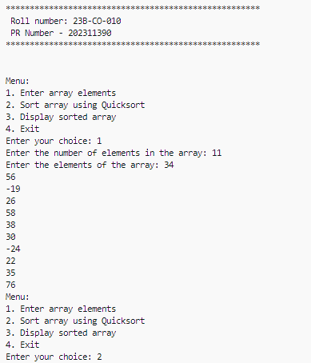

**OUTPUT –**

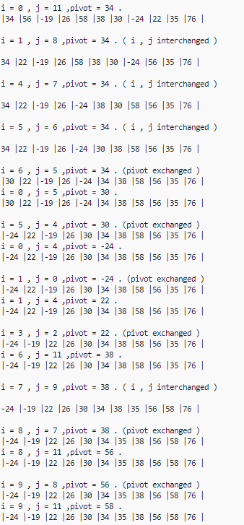 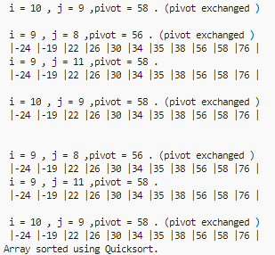

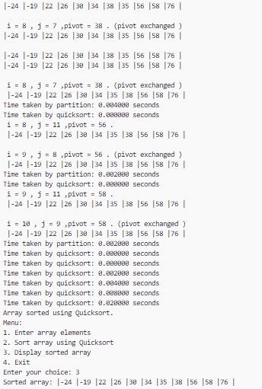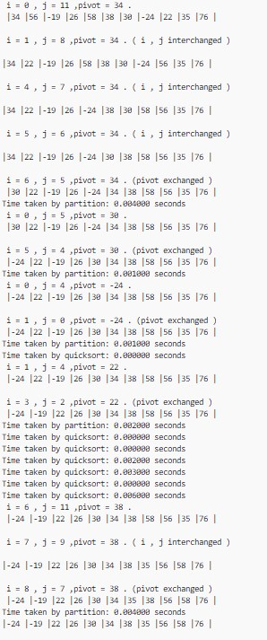

**TIME TAKEN –**



**CONCLUSION -** The array of integers was succesfully sorted using quick sort algorithm without errors

.